Home learning grid - Oak Class
Antarctic: weeks beg 18th and 25th January
Story focus for these weeks will be Lost and Found by Oliver Jeffers.
Teams meeting focus 9.30-9.45- resources needed in blue
Monday Com lang/ UTW | Tuesday Literacy | Wednesday Literacy | Thursday Maths | Friday com and lang/ UTW
Penguin song  Tell me a fact about a penguin | Dough gym- dough  Phonics- paper / card with ch sh th on | Lost and found  What would you put in the suitcase? | Counting games  How many penguins game | Show and tell  certificates

Communication and language  Listening and attention  40-60 I can listen and do for a short span  Understanding  40-60 I can respond to instructions involving a two-part sequence.  I am able to follow a story without pictures or props.  Speaking  40-60 I can link statements and stick to a main theme or intention  I use talk to organise, sequence and clarify thinking, ideas, feelings and events | Kinetic letters  Physical development  40-60 I can begin to form recognisable letters.  I can use a pencil and hold it effectively to form recognisable letters, most of which are correctly formed.  Writing  40-60 I use some clearly identifiable letters to communicate meaning, representing some sounds correctly and in sequence.  I write my own name and other things such as labels and captions.  ELG I can handle equipment and tools effectively, including pencils for writing. | Literacy  Reading  40-60 I can continue a rhyming string  I can hear and say the initial sound in words  I can segment sounds in simple words and blend them together and I know which letters represent some of them  I can link sounds to letters, naming and sounding the letters of the alphabet  I am beginning to read words and simple sentences  ELG I can use my phonic knowledge to decode regular words and read them aloud accurately  I can read some irregular words | Literacy  Writing  40-60  I begin to break the flow of speech into words.  I continue a rhyming string.  I hear and say the initial sound in words.  I can segment the sounds in simple words and blend them together.  I link sounds to letters, naming and sounding the letters of the alphabet.  ELG I can use my phonic knowledge to write words in ways which match my spoken sounds.  I can write some irregular common words | Maths  Number  40-60 I can count up to three or four objects by saying one number  name for each item  I can count objects to 10, and am beginning to count beyond 10  I can estimate how many objects I can see and check by  counting them.  I can find one more or one less from a group of up to five objects, then ten objects  ELG I can place numbers 1-20 in order  I can say which number is 1 more or 1 less than a number to 20
Show and tell Friday  When you have read Lost and Found can you talk about the story and the characters. What details can you remember? | Funky fingers activities help the children develop strength for their pencil grip  - 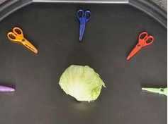 practise cutting. Lots of different textures such as lettuce, card, paper, tin foil, cooked spaghetti, jelly cubes etc  - 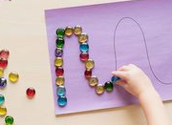follow a pattern using cubes, beads, stones etc  - 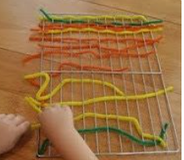 using a wire tray what can you weave through the wires  - 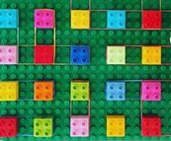 make shapes with elastic bands around lego or duplo  Kinetic letters practise- Bounce and Skip (the monkeys) would like you to practise the slider family. Remember the letters always start from a branch on the tree and bump on the ground or go underground. Follow the rhymes that go with the letters. Say them out loud as you write (pencil grip hold is below)  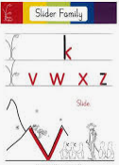  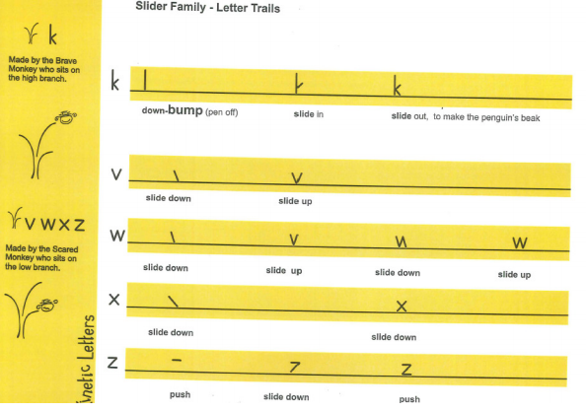 | Read lost and found with your grown up. Look through the book again. Look for words in the text that you can read. Sound them out to help you. Spot your camera words in the text  https://www.youtube.com/watch?v=u73IW68dVrI  can you make a puppet of the boy and the penguin. Use them to retell the story  Teach your monster to read- can you earn a certificate?  Keep reading- share with me any books you are reading to your family at home and let me know what level they are or if they are picture books | Make a penguin book. This one looks like a penguin. As you write down your facts say the sounds of the letters you need. Try to write the sounds even if it is just the initial one for each word. Can you remember any of the camera words  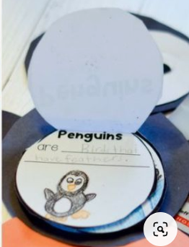  Lost and Found  Make a story map about the story  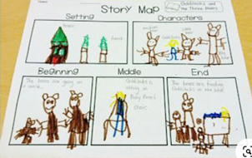  put on your map the title, who the characters are and what happens.  Think about the suitcase the boy took on the journey. What would he need to pack for the journey? Make a list putting the items underneath each other:  Things to pack  Water  Coat  Hat etc  Keep practising writing your name and labels for things around the house | Can you order the numbers to 10 and then to 20?  Put a group of toys on the table. Count how many there are? Get your grown up to take one away- how many are left?  Do it again- this time add one- How many are there?  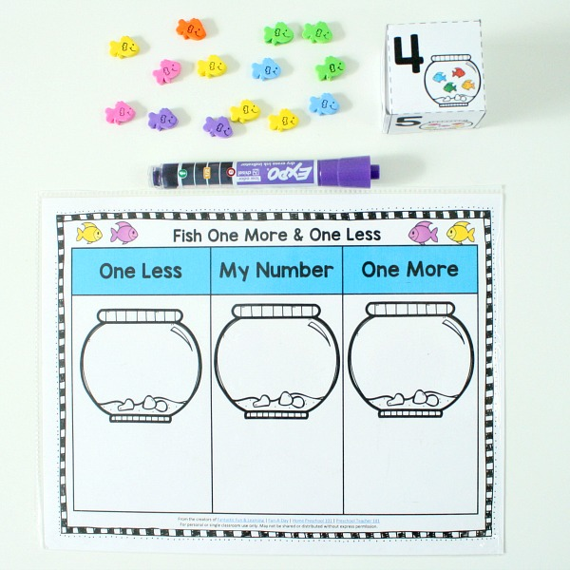  Using the fish bowl template roll a dice or pick a number from ones written on cards 1-10 or 1-20 put the number in the middle bowl. Count out 1 less and 1 more. If you don’t have fish use cubes, lego, pasta etc  https://whiterosemaths.com/homelearning/early-years/growing-6-7-8/  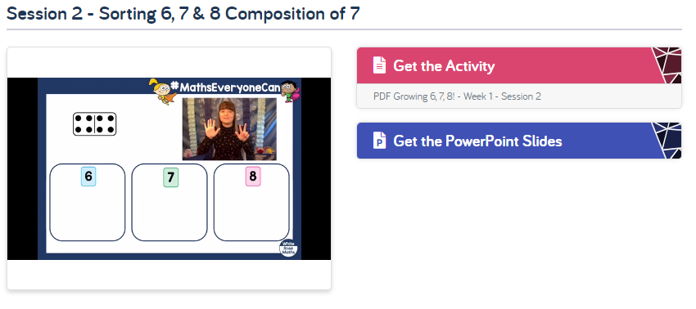  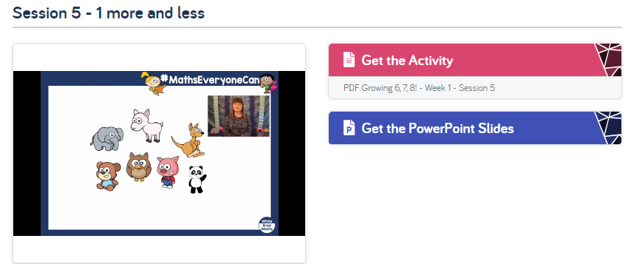  Twinkl has some great penguin maths activities
Maths  Shape space and measure  40-60 I can describe relative position such as ‘behind’ or ‘next to’  I can order and sequence familiar events  I can measure short periods of time in simple ways  ELG I can use everyday language to talk about size, weight, capacity, position, distance, time and money to compare quantities and objects and to solve problems | Expressive arts  Exploring and using materials  40-60 I understand that different media can be combined to create new effects.  I manipulate materials to achieve a planned effect.  I construct with a purpose in mind, using a variety of resources.  Elg I can safely use and explore a variety of materials, tools and techniques, experimenting with colour, design, texture, form and function.  Being imaginative  40-60 I create simple representations of events, people and objects.  I initiate new combinations of movement and gesture in order to express and respond to feelings, ideas and experiences.  I choose particular colours to use for a purpose.  ELG I represent my own ideas, thoughts and feelings through design and technology, art, music, dance, role play and stories | Understanding the world  People and communities  40-60 I enjoy joining in with family customs and routines.  Elg I can talk about past and present events in in my life and in the lives of my family.  The world  40-60 I look closely at similarities, differences, patterns and change.  ELG I know about similarities and differences in relation to places, objects, materials and living things. | Understanding the world  Technology  .  40-60 I complete a simple program on a computer.  I use ICT hardware to interact with age-appropriate computer software.  ELG I select and use technology for particular purposes. | Physical development  Moving and handling  40-60 I travel with confidence and skill around, under, over and through balancing and climbing equipment.  I show increasing control over an object in pushing, patting, throwing, catching or kicking it.  I use simple tools to effect changes to materials.  ELG I can move confidently in a range of ways, safely negotiating space.
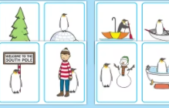  Twinkl- where is the penguin? can you use positional language to say where he is?  Look at the pictures of a penguin’s life. Can you put them in the correct order?  Look around your house to find things that measure or tell the time. What did you find? How do they work?  Make a photo collage of the objects  How many jumps can you do in 15 secs? How many in 30? How many in a minute?  Think of other things you can do in a minute that you can count. | Paint or draw a picture of the boy and the penguin.  If you have a shoe box or something similar make a suitcase for the boy and the penguin to take on their journey. What would you put inside?  can you follow the instructions to draw a penguin? They are quick but watch it a couple of times then have a go!  https://www.youtube.com/watch?v=JFtgelanjgE  if you have a large pebble why not paint it as a penguin.  Mrs Austin’s music plan- see appendix | The penguin and the boy made friends and liked being together. What are your favourite things to do with your friends and family. Make a picture/ poster of these happy things  Think about the boat that the boy and the penguin sailed in to the South Pole. Can you make a boat that floats? Will it hold a penguin and a boy? Make a small penguin and boy to go in the boat. If it sinks what can you do to make it float?  The penguin used the umbrella to float towards the boy. Find things around your house and test what floats and what sinks (check with your grown up that they can get wet)  Take a guess for each object before you test it  Make a chart to show what you found:  Floats Sinks | Choose a penguin species to find out about- can you paste a picture and use a keyboard to sound out some words about it. Get your grown up to help.  Take photos of your work to send to Miss Hillman  Mathletics  Teach your monster to read- log ins sent by email  Andy’s adventures https://www.bbc.co.uk/iplayer/episode/m000ftm9/andys-aquatic-adventures-series-1-13-andy-and-the-chinstrap-penguins  https://www.bbc.co.uk/iplayer/episode/b01cbmy4/andys-wild-adventures-series-1-1-emperor-penguins | Scissor skills- cut along patterns such as spirals, straight lines zigzags  Cut out the penguin and assemble (twinkl)  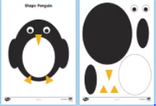  Cosmic yoga- choose a story to follow or do star yoga  Pedro the penguin  https://www.youtube.com/watch?v=jSZvMHlw9vs  What can you do with a ball- create games that involve rolling, catching, bouncing etc  Gonoodle- I’m still standing  Banana banana meatballs  Footloose  Joe Wicks

Phonics.

Dough gym songs: (we choose the ones that show the lyrics so there isn’t a video playing in the background)
Up – Olly Murs
Shine a light – Mcfly
Adventure of a lifetime – Coldplay
Don’t feel like dancing- Scissors Sisters
Cotton Eyed Joe – The Rednecks
Dynamite (clean version) – Taio Cruz

Phonics activities. Ch sh th
- Look through some of your story books for sh ch th. Do they come at the beginning, middle or end of the word? Try and make a list of the words
- 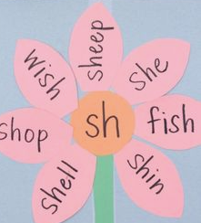 make a phonic flower for sh ch and th. Use some of the words you have found
- Can you spot a camera word? Using your coloured words from your pack look for them in your story books, on food packets, posters etc and pin them with blutac. If you can try and read the sentence they are in, definitely say the word out loud when you find it.
- Code breaker. Write down each initial sound to read the words (below in appendix)

Pencil grip for kinetic letters:
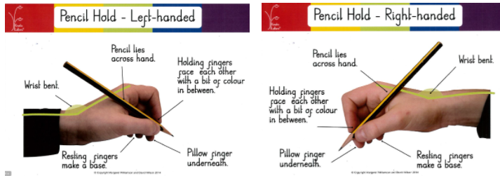

Helpful websites:
https://abcdoes.typepad.com/abc-does-a-blog/2013/09/dough-gym-week-creating-a-dough-gym.html
https://www.phonicsplay.co.uk/
https://www.oxfordowl.co.uk/
https://app.gonoodle.com/
https://www.storybots.com/
https://www.teachyourmonstertoread.com/
vooks.com
https://www.twinkl.co.uk/
cosmic yoga you tube

Playdough recipe: https://www.bbcgoodfood.com/howto/guide/playdough-recipe

Appendix
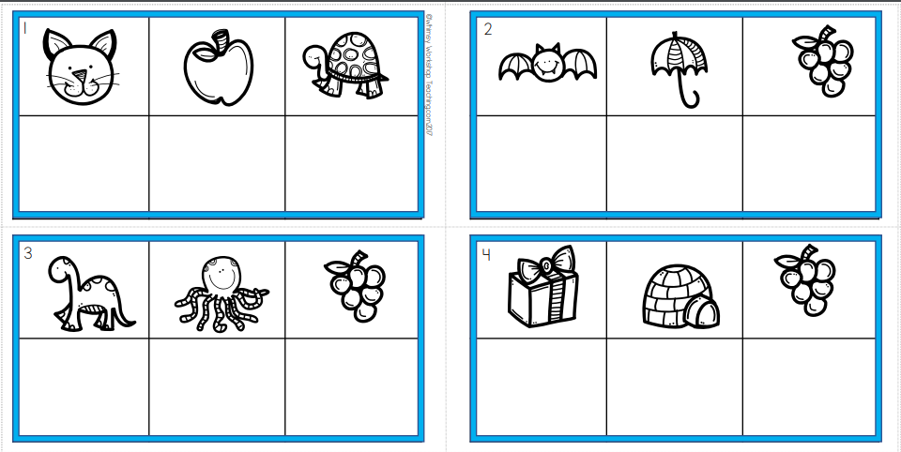
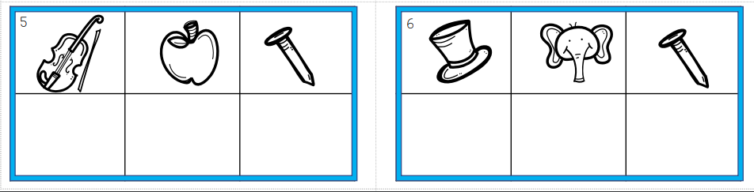

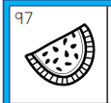= watermelon